ACIDS AND BASES IN AQUEOUS SOLUTIONS 12

1. Which one of the following is NOT a weak electrolyte?

a) Ethanoic acid.
b) Water.
c) Ethanol.
d) Ammonia.

2. The [H⁺] concentration in pure water at 25ºC is equal to

a) 1 mol L⁻¹
b) 10⁻¹⁴ mol L⁻¹
c) 7 mol L⁻¹
d) 10⁻⁷ mol L⁻¹

The next two questions refer to the following information.

When hydrogen chloride dissolves in water, the following reaction occurs:
HCl + H₂O 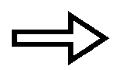 H₃O⁺(aq) + Cl⁻(aq)

3. Which compound is acting as an acid in the above reaction?

a) HCl
b) H₂O
c) H₃O⁺
d) Cl⁻

4. Which compound is acting as a base in the above reaction?

a) HCl
b) H₂O
c) H₃O⁺
d) Cl⁻

The next two questions refer to the information below:

Suppose you were given solutions with the following pH values:

Solution | pH
A | 2
B | 7
C | 6.5
D | 7.5
E | 13

5. Which solution could be described as slightly alkaline?

a) Solution A.
b) Solution B.
c) Solution C.
d) Solution D.
e) Solution E.

6. Which one of the above solutions would react most vigorously, liberating hydrogen gas, when added to some zinc metal?

a) Solution A.
b) Solution B.
c) Solution C.
d) Solution D.
e) Solution E.

7. Consider 1M solutions of sodium hydroxide, ethanoic acid, hydrochloric acid and sulfuric acid. In order of increasing pH, the solutions would be

a) sulfuric acid, hydrochloric acid, ethanoic acid, sodium hydroxide.
b) Hydrochloric acid, sulfuric acid, ethanoic acid, sodium hydroxide.
c) Sodium hydroxide, ethanoic acid, hydrochloric acid , sulfuric acid.
d) Sodium hydroxide, ethanoic acid, sulfuric acid, hydrochloric acid.

8. Which one of the following oxides would you expect to be BASIC?

a) SO₂
b) NO₂
c) Li₂O
d) CO₂

9. The equation below shows the reaction of ammonia with water:
NH₃(aq) + H₂O(l) 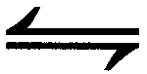 NH₄⁺(aq) + OH⁻(aq)

According to the Bronsted-Lowry theory of acids and bases, the water molecules in the above reaction

a) act as an acid by giving up a proton.
b) act as a base by accepting a proton.
c) act as an acid by neutralising the ammonia.
d) act as an acid by giving up electrons.

10. For the following reaction, NH₄⁺(aq) + HPO₄²⁻(aq)  NH₃(aq) + H₂PO₄⁻(aq), the conjugate acid of HPO₄²⁻ is

a) NH₄⁺
b) NH₃
c) H₂PO₄⁻
d) H₃O⁺

11. For the reaction, HF(aq) + H₂O(l) H₃O⁺(aq) + F⁻(aq), the conjugate base of HF is

a) H₂O
b) H₃O⁺
c) F⁻
d) OH⁻

12. Which one of the following statements concerning pure water at 25ºC is NOT true?

a) k_{w} = 1.0 x 10⁻¹⁴
b) [H⁺] = 1.0 x 10⁻⁷ mol L⁻¹
c) pH is 7.
d) Pure water is classified as a non electrolyte.

13. What is the pH of a 0.01 mol L⁻¹ sodium hydroxide solution?

a) 0.01 b) 2
c) 12 d) 14

14. What is the pH of a 0.001 mol L⁻¹ solution of nitric acid (HNO₃)?

a) 0.001 b) 2
c) 3 d) 10

15. Which one of the following is a weak acid?

a) HCl
b) H₃PO₄
c) HNO₃
d) H₂SO₄

16. All of the following are strong bases with the exception of

a) KOH
b) Ba(OH)₂
c) Ca(OH)₂
d) NH₃

17. Which of the following best defines a strong acid?

a) A strong acid has a high concentration of hydrogen ions.
b) A strong acid is one which fully ionises in aqueous solution.
c) A strong acid has a pH of less than 2.
d) A strong acid is one which turns blue litmus red.

18. The table below shows acid dissociation constants, k_{a} , for four acids, measured at 25ºC.

ACID | FORMULA | DISSOCIATION  CONSTANT
Hydrofluoric Acid | HF | 6.8 x 10⁻⁴
Ethanoic Acid | CH₃COOH | 1.8 x 10⁻⁵
Oxalic Acid | H₂C₂O₄ | 5.4 x 10⁻²
Hydrogen Carbonate Ion | HCO₃⁻ | 5.6 x 10⁻¹¹

Which is the WEAKEST acid shown in the table above?

a) HF
b) CH₃COOH
c) H₂C₂O₄
d) HCO₃⁻

19. How many moles of hydroxide ion would be required to react with one mole of phosphoric acid, H₃PO₄?

a) 1 mole. b) 2 moles
c) 3 moles d) 4 moles

20. Which one of the following salts dissolves in water to give an acidic solution?

a) NH₄NO₃
b) KNO₃
c) NaCl
d) Na₂CO₃

21. The type of reaction in which ions react with water to produce hydrogen ions or hydroxide ion is called

a) neutralisation.
b) hydration.
c) hydrolysis.
d) dissolution.

22. When sodium ethanoate dissolves in water, the ethanoate ions react to a small extent with water to form ethanoic acid and hydroxide ions as follows:

CH₃COO⁻(aq) + H₂O(l) CH₃COOH(aq) + OH⁻(aq)

A solution of sodium ethanoate would be

a) neutral because sodium ethanoate is a salt formed as a result of an acid-base reaction.
b) acidic because ethanoic acid is formed when it hydrolyses in water.
c) basic because the ethanoate ion lowers the [H⁺] to less than 10⁻⁷ mol L⁻¹.
d) slightly acidic because the ethanoic acid formed in aqueous solution is a weak acid.

23. Consider the following statements.

I. The substance should not react with acids or bases.
II. The substance must be available in pure form.
III. The substance should be coloured so it is easily visible.
IV. The substance must be of known formula.
V. The substance must not react with air or absorb water.

The statements that apply to a ‘primary standard’ are

a) I, II. III and IV.
b) I, II and IV.
c) II, IV and V.
d) All of the above statements apply.

Questions 24 to 27 are based on the following information.

A student is instructed to standardise a hydrochloric acid solution. Firstly, the student weighs out exactly 5.30 g of pure anhydrous sodium carbonate into a beaker. Approximately 100 mL of distilled water is added to dissolve the sodium carbonate. The solution is carefully transferred to a 250 mL volumetric flask. The beaker is then rinsed with distilled water several times and the contents poured into the volumetric flask to ensure the complete transfer of the sodium carbonate. Finally, distilled water is added to the volumetric flask to make the volume up to 250 mL precisely.

24. What is the concentration of the primary standard prepared in this way?

a) 0.05 mol L⁻¹
b) 0.1 mol L⁻¹
c) 0.2 mol L⁻¹
d) 0.0002 mol L⁻¹

The student is then given 500 mL of dilute hydrochloric acid of unknown concentration and told to determine its concentration.

A clean burette is rinsed with a little of the acid solution before filling the burette with the hydrochloric acid.
A 20 mL sample of the primary standard solution of sodium carbonate is then accurately transferred to a conical flask and a few drops of methyl orange indicator added.

The balanced equation for the reaction between sodium carbonate and hydrochloric acid is :
2H⁺(aq) + CO₃²⁻(aq) H₂O(l) + CO₂(g)

25. What instrument should be used to accurately measure and deliver exactly 20 mL of the primary standard?

a) A graduated cylinder.
b) An eyedropper.
c) A burette.
d) A pipette.

26. The student then performs the titration a number of times to obtain consistent results.

The diagram below shows the level of hydrochloric acid in the burette immediately before and after one such titration.

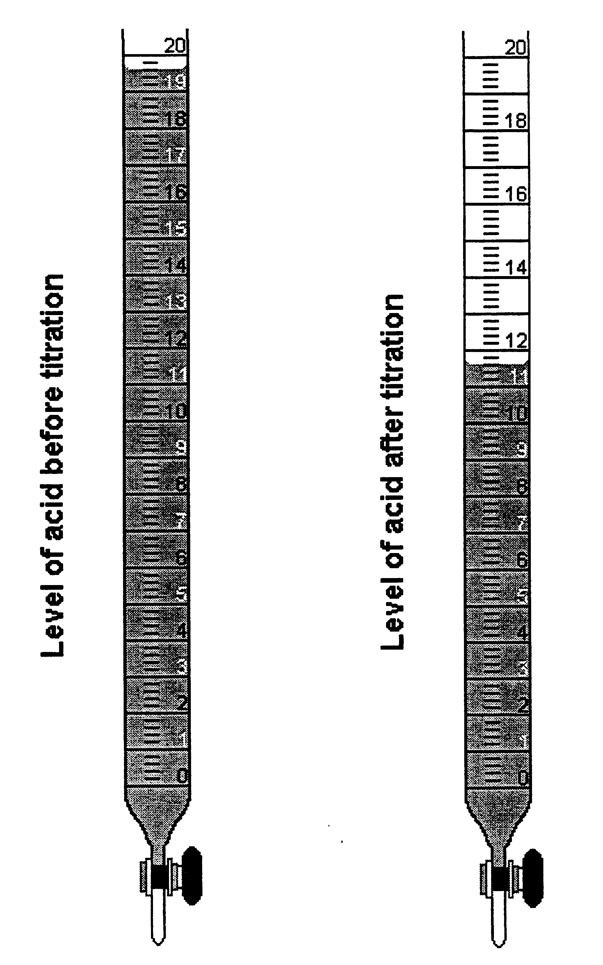

What volume of acid has been used in this titration?

a) 7.0 mL
b) 8.0 mL
c) 8.2 mL
d) 11.6 mL

27. Using the volume obtained in question 26 and other information given previously, what is the concentration of the hydrochloric acid?

a) 0.01mol L⁻¹
b) 0.5 mol L⁻¹
c) 1.0 mol L⁻¹
d) 2.0 mol L⁻¹

28. In volumetric analysis work, the following items of glassware are used:

I. Pipette
II. Volumetric flask
III. Conical flask
IV. Burette

Which of these items must be rinsed with a sample of the solution they will contain prior to them being filled with this solution for a titration?

a) All of them
b) I and IV.
c) I, II and IV.
d) III only.

29. Which of the following is used as a primary standard in acid-base titrations?

a) Hydrochloric acid.
b) Sodium carbonate.
c) Sodium hydroxide.
d) Sulfuric acid.

30. Which one of the following acids is diprotic?

a) Nitric acid.
b) Phosphoric acid.
c) Ethanoic acid.
d) Sulfuric acid.

31. If a solution has a pH of 10, then the hydroxide ion concentration of the solution is

a) 10 mol L⁻¹
b) 0.1 mol L⁻¹
c) 0.04 mol L⁻¹
d) 0.0001 mol L⁻¹

Questions 32 and 33 refer to the table of indicators below.

Name of Indicator | pH Range | Colour  (low pH – high pH)
Methyl red | 4.4 – 6.2 | Pink – yellow
Methyl orange | 3.1 – 4.4 | Red – yellow
Bromothymol blue | 6.0 – 7.6 | Yellow – blue
Phenolphthalein | 8.3 – 10.0 | Colourless – red
Litmus | 5.0 – 8.0 | Red – blue
Alizarin yellow | 10.1 – 12.0 | Yellow – lilac
Cresol red | 0.2 – 1.8 | Red - yellow

32. Which of the following indicators would be best for the titration between hydrochloric acid and sodium hydroxide?

a) Cresol red.
b) Alizarin yellow.
c) Bromothymol blue.
d) Any of the indicators in the table above would be suitable.

33. If methyl orange indicator is used in a titration between a standard solution of sodium hydroxide (in a conical flask with indicator) and ethanoic acid (added from a burette), then

a) the end point would occur at the equivalence point of the titration.
b) the end point of the titration would occur before the equivalence point has been reached.
c) the end point of the titration would occur after the equivalence point.
d) no colour change would occur.

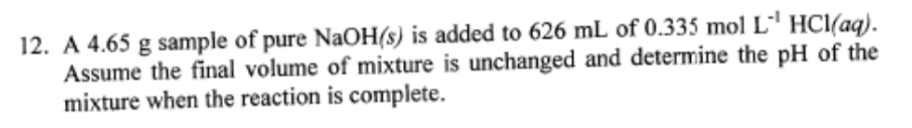

ACIDS AND BASES 12

1. c  2. d  3. a  4. b  5. d  6. a  7. a  8. c  9. a  10. c | 11. c  12. d  13. c  14. c  15. b  16. d  17. b  18. d  19. c  20. a | 21. c  22. c  23. c  24. c  25. d  26. b  27. c  28. b  29. b  30. d  31. d  32. c  33. c

